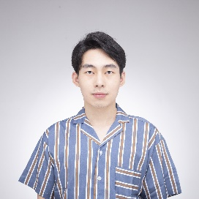
z

Jinda Li Game Developer

jinda.li@outlook.com
https://neiljnda.github.io/
https://www.linkedin.com/in/jinda-li/





PROJECT EXPERIENCE

They Are You Roles: Programmer (team of 8)
Best Student Game of Finland, Second Place, Bit1 Competition 2022. “You become who you kill”
- Designed and developed a data-driven code structure with Unity and C#.
- Programmed main gameplay content including character control, transformation logic, combat system, logic/graphics of vision, etc.

They Are You Roles: Programmer (team of 8)
Best Student Game of Finland, Second Place, Bit1 Competition 2022. “You become who you kill”
- Designed and developed a data-driven code structure with Unity and C#.
- Programmed main gameplay content including character control, transformation logic, combat system, logic/graphics of vision, etc.
Find all my games at https://neiljnda.github.io/

WORK EXPERIENCE


Unity Developer Feb. 2024 - Mar. 2025
Mixed Reality, Microsoft
Re
Cross-platform VR Tools: Developed Unity-based AR-in-VR simulator for research, integrating holographic rendering, eye-tracking, night vision, etc.
HoloLens2 Applications: Engineered AR applications with gesture-based interactions.


AI Game Developer Sep. 2023 - Apr. 2024
AI-Driven Open World Engine, Microfeel
Start-up company focusing on Generative AI and UGC in Games
Implemented AI procedural building generation using LLMs in Unreal.
Pioneered 3D Gaussian Splatting rendering in Unity for real-time photorealistic scene reconstruction.

Game Designer Intern May. 2021 - Jul. 2021
Naraka: Bladepoint, NetEase Games
Action-adventure battle royale game, 180k concurrent steam players at peak
Participated in the combat design and streamlined animation pipelines.
Optimized movement experience for complex combat environments.
Contributed to new battle map design concepts


SKILLS
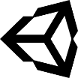 |  |  | 
VR/AR | Unreal | C++/C# | Shader
 |  |  | 

 |  |  | 
VR/AR | Python | Git | JavaScript
 |  |  | 
 |  |  | 
React | Parallel Programming | Blender | Linux
 |  |  | 


EDUCATION
Electrical Engineering, Southeast University (China)
Bachelor of Engineering 2016-2020

Game Design and Production, Aalto University
Master of Science 2021- 2025

